 | If this summary has helped you, I would appreciate your support. | 
Table of Contents
1. Introduction 1
2. Cellular 3
3. WiFi 10
4. ZigBee – IEEE 802.15.4 13
5. Bluetooth & Device Pairing 15
6. RFID 17
7. Lessons Learned (duplicates left out) 19
8. Socio-Tech Lectures 20

Introduction

IoT / Pervasive Computing
Information processing (including sensing), networking and response anywhere, anytime
- Pervades everyday life
- Context-awareness
- Connected
- Sensors deliver information about physical environment
- Actors (actuators) response to physical environment
Enablers: Cheap, Small, Fast, Connected, Advanced UI

Security
To protect the right things, in a right way
Goals, Threats, Means: Protect what against whom, how

Security Goals:
- Confidentiality: Protect data from unauthorized reading access
- Integrity: Protect data from unauthorized changes
- Availability: Make data always available on request by an authorized entity
→ Key is Authentication

Privacy
Past: The right to be left alone
Today: Informational self-determination; when, what, how and to whom data is passed on

S&P in IoT
- Different/new quality and quantity of data
- Profiling: habits, emotions (detected and processed via cameras and audio)
- Devices observe and interact with the physician environment
- Unprecedented data collection scale & attack surface

Security & Privacy Assessment
- System description
- Security & Privacy goals
- Other goals
- Attacker model
- Tradeoffs

Attacker Model (ARID):
- Actors
- Resources
- Incentives (motivation)
- Damage

Design Principles for Pervasive Systems
- Default to Harmlessness: In case of system failure, degradation of services
- Be Deniable: Opt-out at any time
- Self-Disclosing: Ownership, Usage, Capabilities must be easy to find out
- Save user’s face: No harassment and embarrassment
- Save user’s time: High usability

Kerkhoff’s Principles
- Practically
- No security by obscurity
- Key is communicable, retainable and changeable
- Applicable to telegraphic correspondence
- Portability
- Easy to use

Abbreviations
Abbreviation | Meaning
IoT | Internet of Things
WAN | Wide Area Network
WLAN | Wireless Local Area Network
WPAN | Wireless Personal Area Network

Cellular

GSM Features
- Communication
- Mobility
- Worldwide connectivity
- High transmission quality

GSM Architecture
Subsystem: | Structure:
NSS (network and switching subsystem):  Call forwarding, handover, switching | 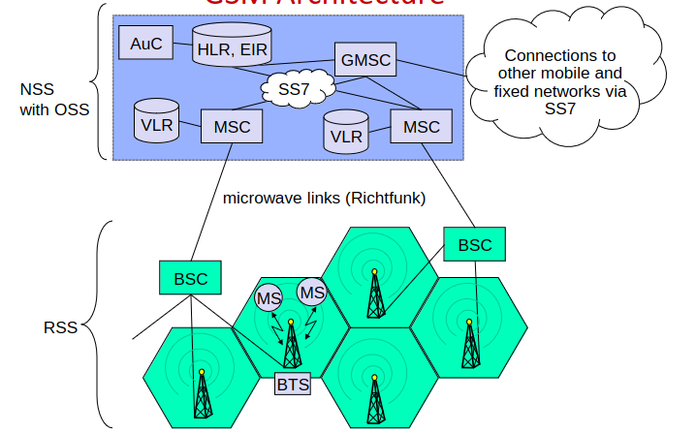
OSS (operation subsystem)
Management of the network
RSS (radio subsystem)
Covers all radio aspects

Radio Subsystem RSS
MS (mobile station): IMEI, SIM card
BTS: base transceiver station
BSC: base station controller
– Manages several BTSs
IMEI (international mobile equipment identifier)
SIM card
- IMSI: International mobile subscriber identifier
- TMSI: Temporary mobile subscriber identifier

Network and Switching Subsystem NSS + Operation Subsystem OSS
HLR: home location register
– Knows the current MSC/BSC of the subscriber
– EIR: equipment identity register contains IMEIs of all registered customers
– AuC: authentication center contains symmetric cryptographic keys shared
with the SIM cards
MSC: mobile switching center
– Manages several BSCs
VLR: visitor location register (database at MSC
Receives data from HLR for subscribers currently connected to its BTSs
GMSC: gateway MSC

GSM Authentication
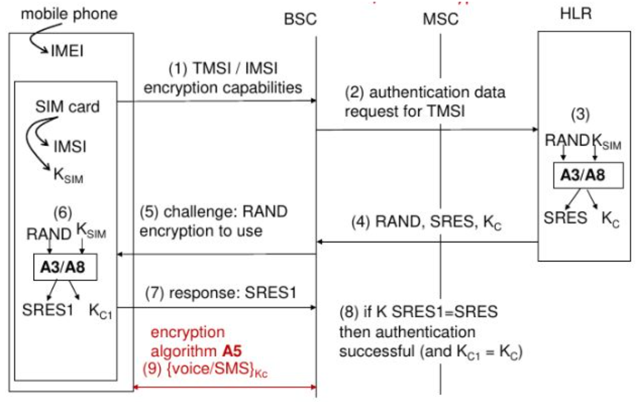

GSM Hacks

Free Call Hack by Ross Anderson
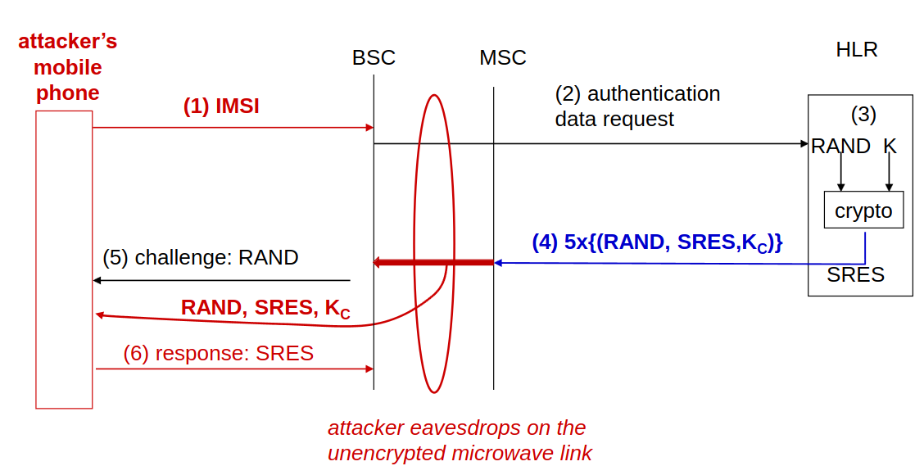

In general Eavesdropping
By eavesdropping the unencrypted microwave link between BSC and MSC, K_{C} is known to the attacker.

Man in the middle attack with IMSI-Catcher
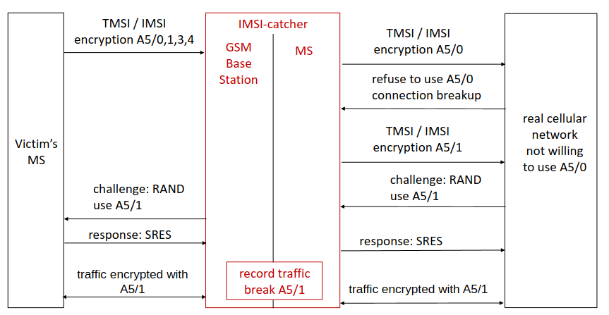

A5/0 = Unencrypted; A5/1 can be broken in real time

SIM Card Cloning
- Physical Extraction of private SIM-Key (very hard)
- Cryptographic Breaking of A3/A8-Encryption-Algorithms with plaintext-attack

UMTS Authentication
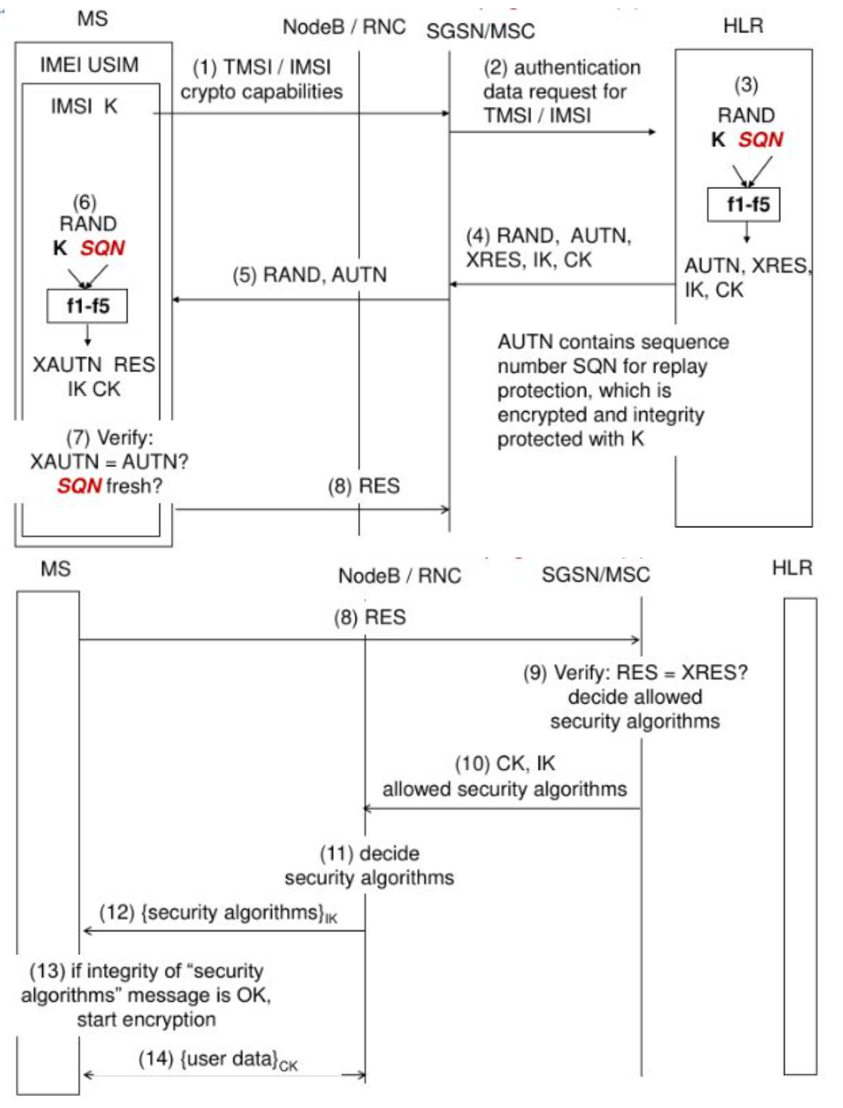

UMTS Degradation Attack
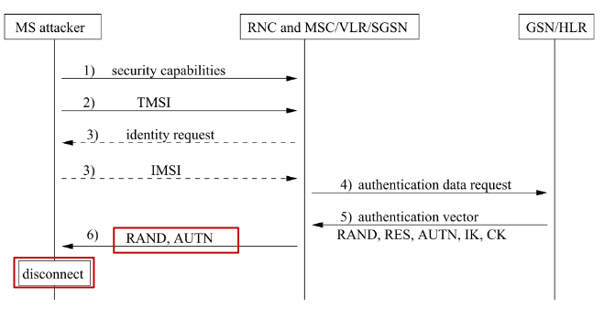
Now we have a valid AUTN
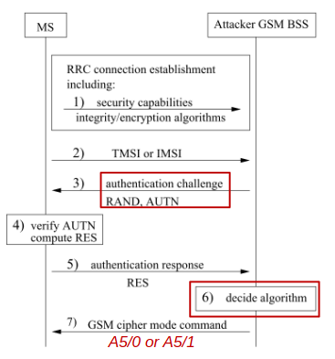
Problems: Backward Compatibility & No Integrity check in GSM

Tracking
- Via SS7: Everyone can buy an access
  - Location Tracking: Getting IMSI and cell id of phone number
  - Eavesdropping: Getting Authentication and Encryption keys for TMSI
  - Manipulation: Forwarding IMSI traffic to specific network
→ Stealing money by redirecting SMSTan to attacker’s network
- IMSI Catcher: Location targeting

LTE Impersonation Attack
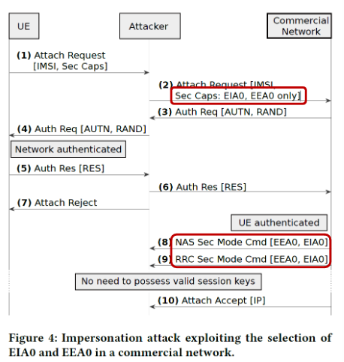
Setting the used encryption to EIA0 (= Unencrypted) as a man in the middle attacker.

LTE Attacks
- GUTI (= TMSI for LTE) rarely change → Location Tracking
- Location leaks via paging requests to eNodeBs
- Location leaks by impersonating eNodeBs: Can ask for signal strength of all surrounding cells
- Degradation attack

aLTEr attack: Voice calls use stream cipher with weak integrity check → Bitflips
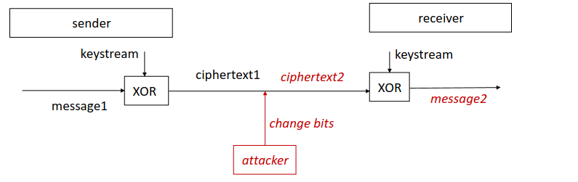

ReVoLTE attack: Keystream reuse attack
Actions | Knowledge of attacker
- Sniffing Call A:
- Making Call B:

- Reversing:

WiFi

WiFi Design Goals
- Global, seamless operation (IEEE 802.11)
- Low power for battery use
- No special permission and license needed
- Robust
- Easy to use
- Low radiation
- Secure

Public Hotspots
- Hidden ESSID (Security by Obscurity) → Active scanning of device is detectable + Replay attack
- MAC Address Filtering → MAC-Address Spoofing
- Evil Twin attack

WEP (Wireless Equivalent Privacy)

Encryption (reversible stream cipher)
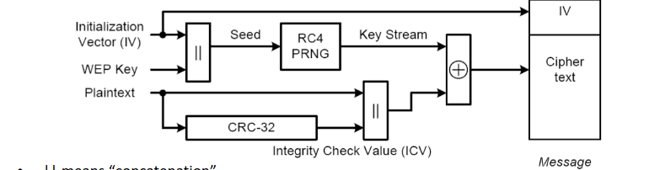

- CRC (Cyclic Redundancy Check) is very weak integrity check
- If IV is used more than once, attacker can make two times pad attack
  - PRNG restarts at 0 on reboot of device
  - IV restarts at 0 on reboot of device
  - IVs are too small and reused after around 7 hours
- RC4 is broken
- Master key is directly used for encryption (same for every device), no session keys

WEP replay attack
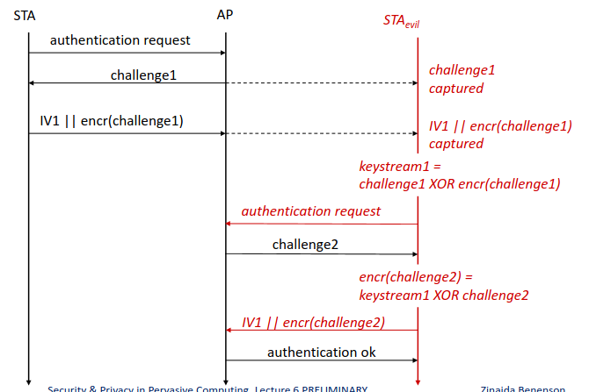

WPA2 (WiFi Protected Access 2)

Key Hierarchy
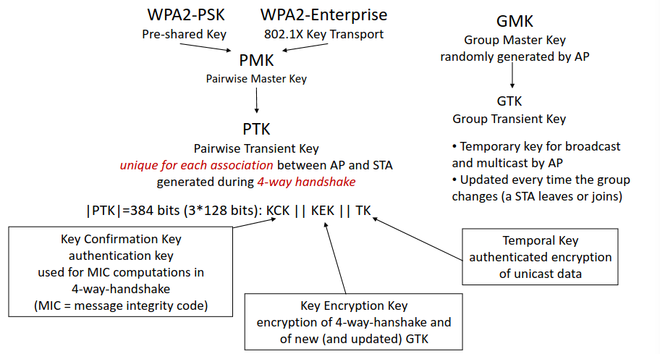
- Master key is never used for encryption → Transient Keys
- Individual keys for each connected device

WPA2-PSK | WPA2-Enterprise
PMK = PBKDF2(WiFi-Password, ESSID)  ESSID = Salt | PMK is sent encrypted from an authenticated Server tunneled through AP

Four-Way Handshake
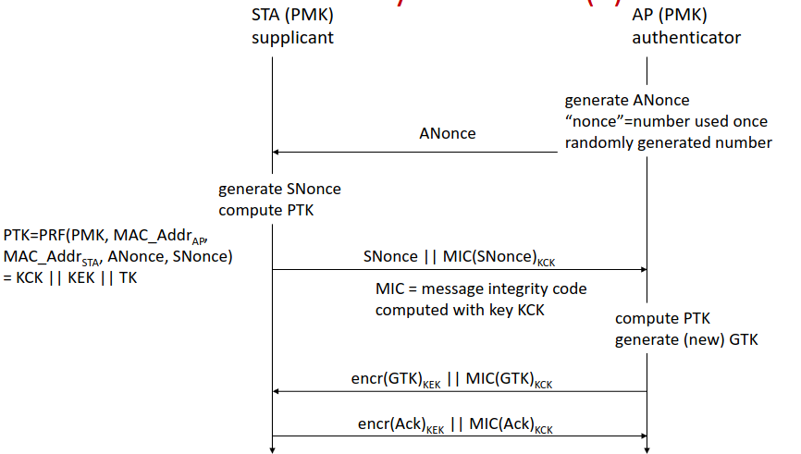

- WPA2-PSK Key Cracking: Capture handshake → Bruteforce password
- WPA2-PSK Insider attack: The same PMK is used for all devices → Capture Nonces → Decryption

Hole 196 attack in WPA2 (Insider attack also for WPA2-Enterprise)
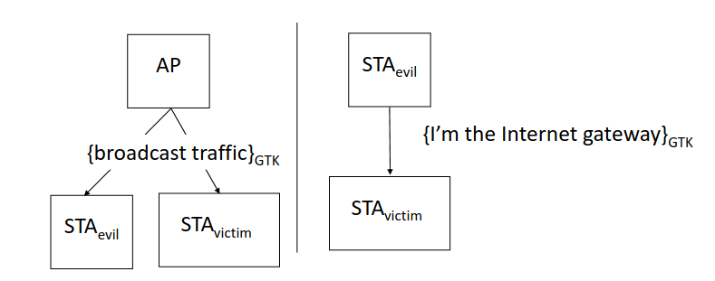
ARP updates
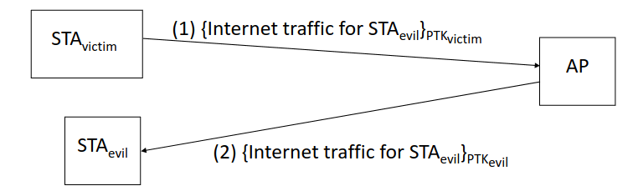

Defenses: Static ARP tables or monitoring of ARP updates

WPA2 Key Reinstallation Attack – Man in the middle attack
- Attacker blocks 3rd message of four way handshake
- Device reinstalls the PTK in stream cipher mode (CTR)
- Attacker blocks these messages, more are sent by device with repeated IVs
→ two times pad attack

Dragonblood attack in WPA3: Downgrade attack to WPA2

ZigBee – IEEE 802.15.4

Design Goals
- Longer range than Bluetooth
- Lower power, data rate and complexity
- Multi-month to multi-year battery life
- Only Sensor data, control commands, No voice or multimedia
- Small code size, less operations to implement

Nodes & Network
Past: Application Profiles; Problem: Several profiles had to be supported
Today: ZigBee PANs (Personal Area Networks)
- ZigBee Coordinator (C) in centralized mode
- ZigBee Router (R)
- ZigBee End Device (E)

ZigBee Authentication
Centralized | Distributed
EZ-Mode only!  Individual device key is transferred to Coordinator by scanning QR code with app.  If not available both share a public global trust center link key | EZ-Mode vs. Touchlink  Both parties share an NDA-protected key.  The one for Touchlink has been leaked in 2015.

Whole Network uses one Network Key for symmetric data encryption.

Touchlink Commissioning
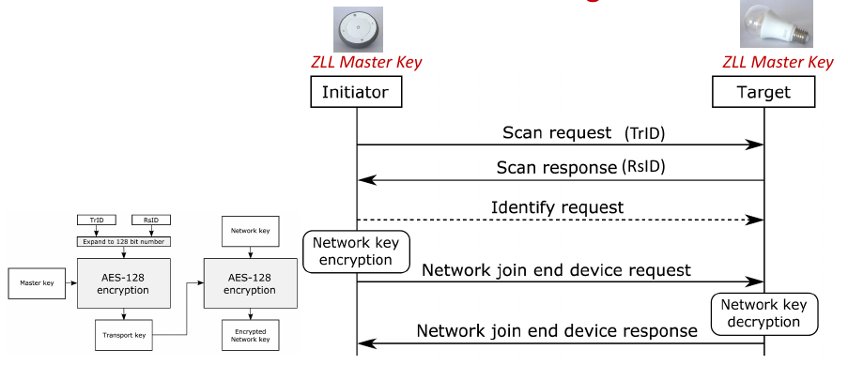

Network key is encrypted without integrity protection (AES-ECB) → device joins any network with any network key

Touchlink Inter-PAN attacks
Inter-PANs are commands that are sent after a scan request and scan response, but before the authentication handshake and mostly work even if the device is already connected to a network.
Inter-PANs are accepted if the device received a scan request with the same TrID before + Bug in proximity check (factory reset is missing proximity check)
These can be used to open smart door locks, DoS or ransom attacks
- Identify Action Attack: Send “Identify request”
- Reset to Factory Attack: Send “Reset to factory request”
- Permanent Disconnect Attack: Send “Network update request”
  - to change wireless channel of target
  - to join target to garbage network, as network authentication is lacking integrity protection

Touchlink Attack using the leaked key
- Hijack: Send network update to connect target to attacker’s network and remote control it
- Network key extraction: Capture authentication handshake and decrypt it

Bluetooth & Device Pairing

Bluetooth 1.0 – 2.0 Key Hierarchy
Initialization Key (PIN) | Link Key | Encryption Key
Temp key for handshake | Generated from Init-Key,  Checked on Re-pairing | Generated from Linked key,  Data encryption

Initialization Key Generation
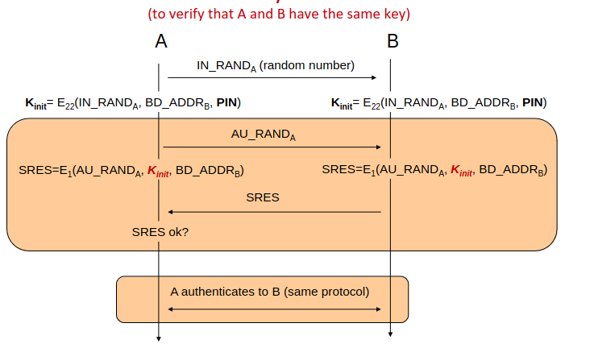
PIN can be cracked by brute force → Decryption + Impersonation attack through “Forgot Key”

Link Key Generation
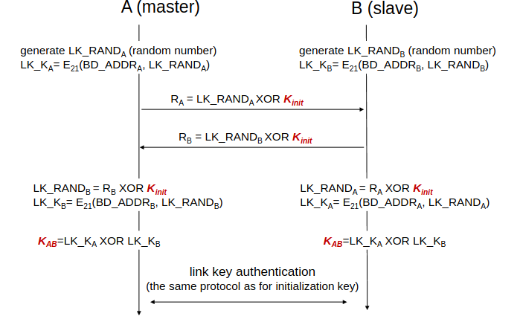

Unauthenticated Diffie-Hellman
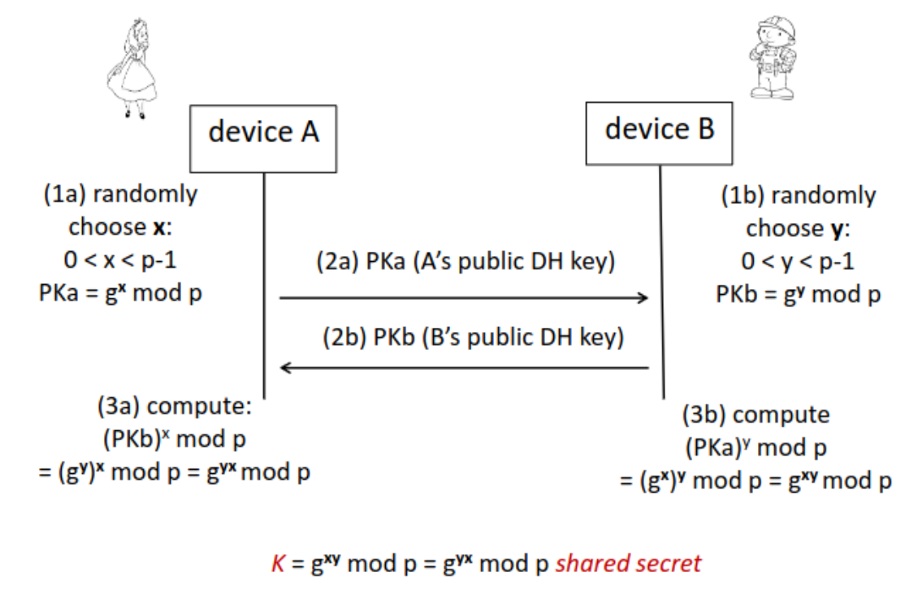
Save against: Passive Eavesdrop
Vulnerable against: Man in the middle, Evil Twin

Authenticated Diffie-Hellman (Bluetooth 2.1+)
Diffie-Hellman with authenticity check via a different OOB channel or secret
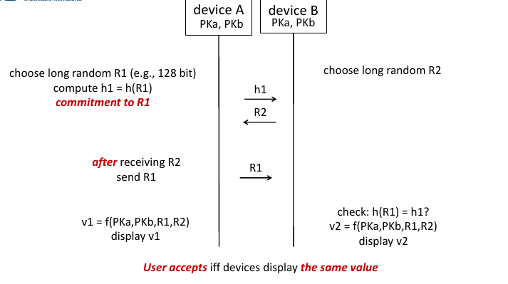
- Manual authentication (MANA): PIN, Push button, compare strings
- Numeric comparison
- Passkey Authentication (PIN input)
- Physical: NFC, USB
- QR Code scanning (Seeing is believing)
- Shake well before use
- Network in a box (Infrared)
- Touch to pair
- Wanda detect
Bluetooth allows degradation to unauthenticated Diffie-Hellman, if rest fails → Degradation attack

RFID

Applications
- Security and Safety (access control, verification, e-documents)
- Tracking (supply chain, hospital)
- Authenticity (medicine)
- Electronic Payment (ApplePay)

Supply chain management
EPC (Electronic Product Code): Unique identifier for every physician object

Retail
Smart shopping carts, smart shelves → Smart payment, stock accuracy, theft detection

Collision detection
Query Tree Protocol | Query Slot Protocol
Reader walks through binary tree, asking for Tag IDs that start with the current number | Reader creates slots, Tags join them randomly. Reader asks for a random 16 bit number for each Tag in each slot. If multiple Tags in one slot, increase and unchecked Tags reorganize.
Deterministic  Tags have no state, only send ACKs | Probabilistic, very efficient  Tags only send RN16 numbers
Reader exposes/asks for all Tag IDs | Tags need random number generator hardware and storage for saving checked flag

Security & Privacy Threats

Security
- Corporate espionage: Unauthorized readers
- Competitor/Market analytics: Consumer analysis through unauthorized readers
- Vulnerable Infrastructure: Jamming
- RFID malware: SQL injection as Tag-ID response

Privacy
- Actions, Preferences, Identity and Location Tracking

Countermeasures
- Killing: Non-recoverable, killing PIN
- Covering: Physical
- Blocking: Jamming → Dozens of Collisions
- RFID Bill of Rights

Ghost-and-Leech attack
Man in the middle attack on unauthenticated Diffie-Hellmann:
Relay/Intercept authentication by emulating RFID card and reader (missing integrity check), attacker needs to be near victim
Defense: Proximity check through Distance-Bounding-Protocols, but they are much slower

E-Passport
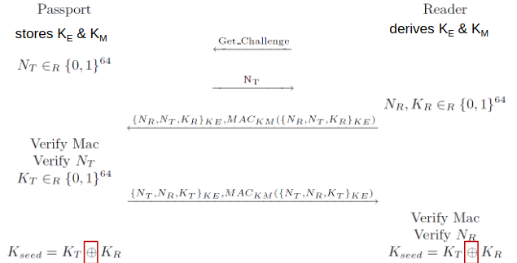
- Symmetric encryption based on personal data in the passport
- Passport has to send message first to reader to protect replay attacks

Information gathering attack
Passports have different responses based on the country

Cloning Attacks
Possible to generate keys if some passport information is known.

Tracking via replay attack
- Capture handshake with Nonces
- Spoof MAC address → A failed MAC check is reported sooner than a failed nonce check
(a failed Nonce means, that the MAC check before was correct → Location tracking)

Lessons Learned (duplicates left out)

Cellular
- No Security by Obscurity
- Mutual authentication of both parties
- Crypto algorithms easy to change (no hardware algorithms)
- Transparent development process
- Backwards compatibility leaves vulnerabilities → Downgrade attacks
- Specification must warn about non-secure modes and define security goals and threat model
- Analytical measures can impact security and privacy

WiFi
- No master keys for data encryption → Session keys + key management
- Secure integrity checks
- User passwords will be weak → Avoid user generated passwords
- Insider attacks must be considered
- Unexpected interaction with insecure 3rd party protocols (ARP in Hole 196)
- Specification clear and not ambigious

ZigBee
- No proximity verification using signal strength
- Encryption only with integrity protection

Bluetooth
- Security assumptions are important
- Do not rely on user generated passwords, they are not random
- Avoid user interaction

RFID
- Think before use
- Also secure backend
- Security & Privacy issues without cryptography
- Implementation mistakes & Hidden functionality

E-Passport
- Crypto keys must be (pseudo-)random
- Side channel attacks: Different responses based on country, timing of messages

Socio-Tech Lectures

Ubiquitous Computing
“Ubiquitous computing names the third wave in computing, just now beginning. First were mainframes, each shared by lots of people. Now we are in the personal computing era, person and machine staring uneasily at each other across the desktop.
Next comes ubiquitous computing, or the age of calm technology, when technology recedes into the background of our lives.” — Mark Weiser

Mark Weiser’s Vision
Tabs | Pads | Active Bagdes
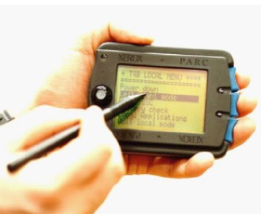 | 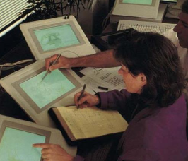 | 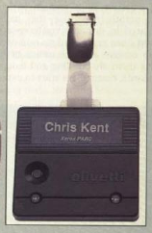
Smartphone in cheap,  Only displays information | Non-individualize e-papers | Smartcard for identification
Computers vanish into the background become invisible, machines that fit the human environment
→ No multi-use personal computer, many single-use computers for one user instead

Case Study: Smart Cities in India
- Smart parking did not fit city needs
- It also did not fulfil expectations
- Suffered from a lack of demand
- Application of technical solutions to problems that cannot be solved solely through technological means – “technological solutionism”
- Command and Control Centers in almost all city plans of Smart Cities Mission

Cybernetics
Cybernetics is a central historical precursor and guiding idea behind many contemporary phenomena, especially smart cities, but also other forms of ubiquitous computing.
- Derived from the Greek word „kubernetes“, or steersman
- Developed by Norbert Wiener during and after WWII
- Foundational for cybernetic contributions in all kinds of disciplines and fields
- Intellectual movement in the 1950s/60s/70s
- A specific procedure for the production of truth through feedback of information
Properties:
- Systems thinking
- Governance as steering
- Horizontal networking
- Organicist thinking
- Frictionless, apolitical understanding of process

Support
If this summary has helped you and you would like to help me invest even more time and energy in further scripts, I would be very happy about your support.
These scripts always cost a lot of time and energy in addition to the normal exam preparation and you would show me that it is worth the effort. These small amounts don't carry any financial weight, but above all they keep my motivation high to continue in the future.

